Software Development for Mobile Devices

# Submission for Assignment 1.2P

## Task 2. Screen resolutions

Display three images in three different device resolutions



Figure : Display three images in three devices

**resolution-layout.xml**

<?xml version="1.0" encoding="utf-8"?>  
<android.support.constraint.ConstraintLayout  
 xmlns:android="http://schemas.android.com/apk/res/android"  
 android:layout_width="match_parent"  
 android:layout_height="match_parent">  
  
  
 <LinearLayout  
 android:layout_width="match_parent"  
 android:layout_height="match_parent"  
 android:orientation="vertical">  
  
 <TextView  
 android:layout_marginLeft="5dp"  
 android:layout_width="match_parent"  
 android:layout_height="wrap_content"  
 android:text="This is a vector image" />  
  
 <ImageView  
 android:layout_width="100dp"  
 android:layout_height="100dp"  
 android:src="@drawable/ic_dog"/>  
  
 <TextView  
 android:layout_marginLeft="5dp"  
 android:layout_width="match_parent"  
 android:layout_height="wrap_content"  
 android:text="This is a png" />  
  
 <ImageView  
 android:layout_width="100dp"  
 android:layout_height="100dp"  
 android:src="@drawable/car"/>  
 <TextView  
 android:layout_marginLeft="5dp"  
 android:layout_width="match_parent"  
 android:layout_height="wrap_content"  
 android:text="A jpeg image" />  
  
 <ImageView  
 android:layout_width="100dp"  
 android:layout_height="100dp"  
 android:src="@drawable/station"/>  
 </LinearLayout>  
  
</android.support.constraint.ConstraintLayout>

### Scale up image on XHDPI device

The reason that we should not use low-density images for xhdpi screen is because that the image is not able to display in a good resolution. It automatically being scaled to the correct size and eventually the image is blur as the image below.

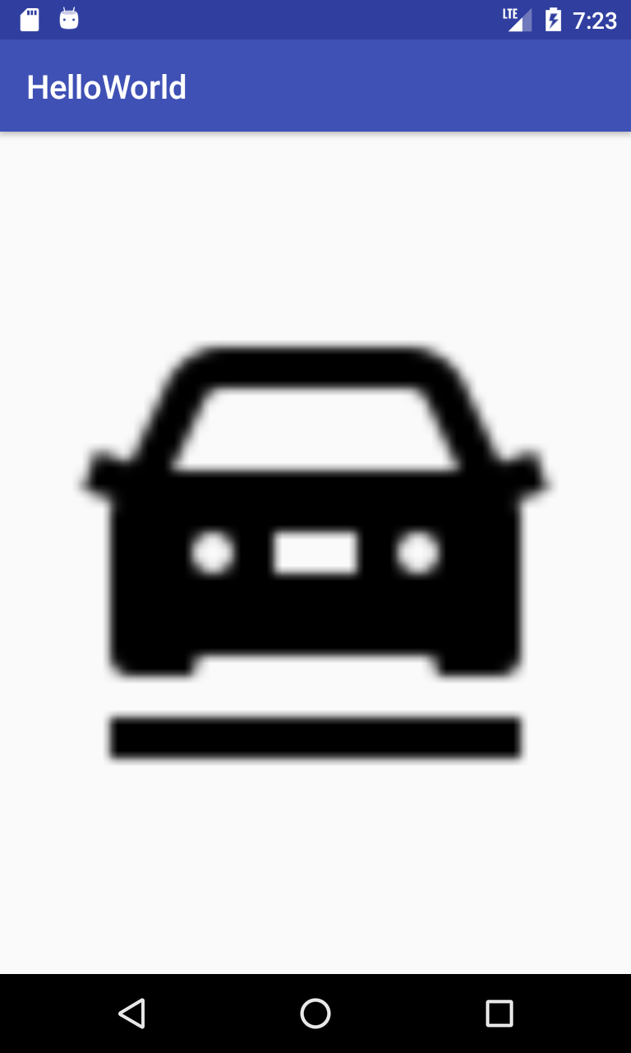

Figure : Display low density image on XHDPI device